Workforce Data Report
(Public Sector Equality Duty Report)
As at 31 July 2024

Contents
1. Introduction 3
2. Workforce Data Review 3
3. Conclusion 7
4. Arrangements for Review 7

Introduction

The Mid and South Essex Integrated Care Board (ICB) recognises the values and diversity of our workforces and the population we serve and through our People Strategy aim to become an employer of choice.

Our Equality, Diversity, Inclusion and Belonging (EDIB) Strategy (approved by the ICB Board in November 2024) sets out the process by which the ICB will develop, over the next four years, it’s approach to EDIB to demonstrate how we deliver our equality aims and objectives, linked to the three equality aims set out within the Public Sector Equality Duty (PSED).

The principal objective of the PSED is one of ‘due regard’ or proper consideration of the need to address the three equality aims:
- Equality aim 1: eliminate discrimination, harassment, victimisation and any other conduct that is prohibited by or under this Act,
- Equality aim 2: advance equality of opportunity between persons who share a relevant protected characteristic and persons who do not share it,
- Equality aim 3: foster good relations between persons who share a relevant protected characteristic and persons who do not share it.

In order to achieve the equality aims and its objectives as an employer, the ICB needs to understand the profile and experience of its workforce. It does this by analysing workforce data, using the Workforce Race and Disability Equality Standards tools, undertaking pay gap assessments and partaking in the NHS Staff Survey as well as conducting internal ‘pulse’ surveys.

In establishing the EDI Strategy, the ICB assessed workforce data as at 31 July 2024. This report sets out the ICB workforce data at that time.

Workforce Data Review

The data presented in this report was collated using the Electronic Staff Record as at 31 July 2024.

The ICB has a diverse workforce that includes people of different sex, age, race, sexual orientation, religion or belief, disability, and marital status. We are committed to encouraging and supporting these diversities in all we do.

Based on our corporate workforce data, MSE ICB’s workforce is made up of a majority of female employees (80%) (see fig. 1). Whereas the gender split of the MSE population is 51% female, 49% male.
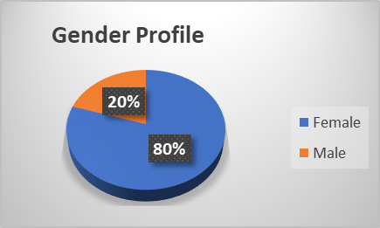
Figure 1: Distribution of MSE employees by sex

The majority of the ICB’s workforce is aged between 36-60 (73%), with a fairly equal split between the age ranges 36-40 (11%), 46-50 (15%), 51-55 (14%) and 56-60 (13%). The larger element is 19% of our workforce being 41-45 years, as shown in fig. 2.
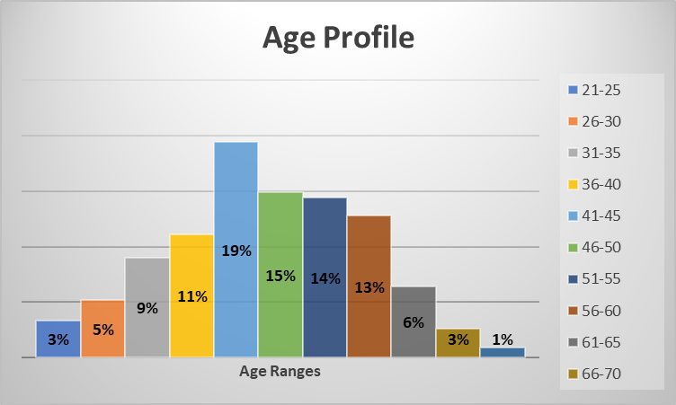
Figure 2: Distribution of MSE employees by age

A high level of ICB staff feel comfortable reporting their race, with 2% unknown (see fig. 3). Much like the racial diversity across the population of MSE, the majority of our workforce are white. 81% of our workforce, compared to 83% of our population in MSE are white. Of the 17% of ethnically diverse groups, 52% were of Black African and 21% were of Indian origin.
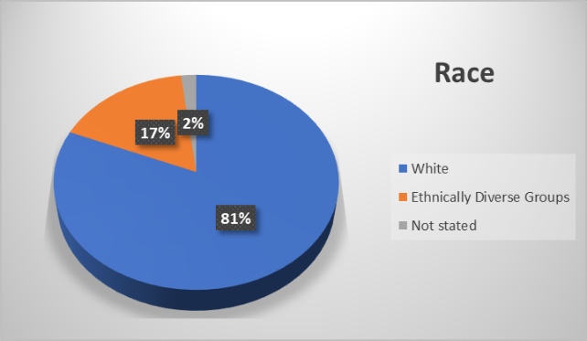
Figure 3: Distribution of MSE employees by race

Of the staff who responded to the most recent survey, 84% stated they were heterosexual, with 6% stating they were gay/lesbian/bisexual, 10% preferred not to disclose (see fig. 4).
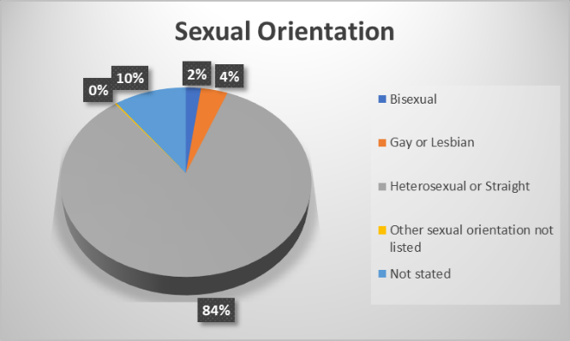
Figure 4: Distribution of MSE employees by sexual orientation

Christianity was the majority religion/belief at 49%, with atheism the second at 20% (see fig. 5). A proportion (20%) of our workforce preferred not to disclose or left blank the data that records religion or belief.
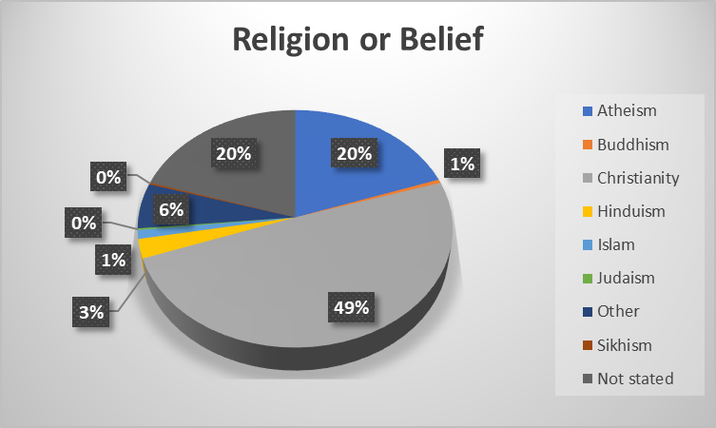
Figure 5: Distribution of MSE employees by religion or belief

8% of the ICB workforce stated they had a disability, with 9% recorded as ‘disability unknown’, 83% stated they did not have a disability (see fig. 6).
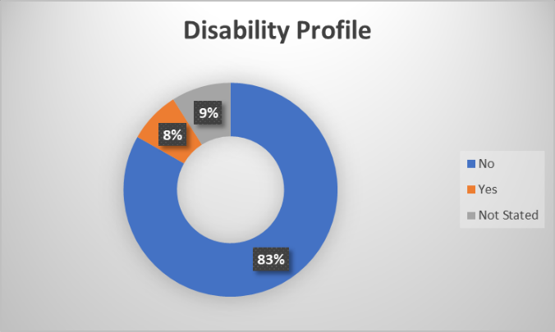
Figure 6: Distribution of MSE employees by disability

Supporting people to feel comfortable to declare their disabilities and religion is key to ensure that the ICB delivers effectively on our requirement to make reasonable adjustments to support our colleagues with a disability or need for support in following their faith. The ICB needs to work with staff so that everyone feels comfortable to declare whether they have a disability or not. This will ensure that anyone who has any kind of disability and requires reasonable adjustments can be supported to receive them as an employee of the ICB. The ICB needs to ensure that has truly inclusive recruitment processes and is recognised as an employer of choice for all.

60% of the workforce stated they were married, 26% stated they were single. 2% of our workforce did not provide information relating to their marriage or civil partnership (see fig. 7).
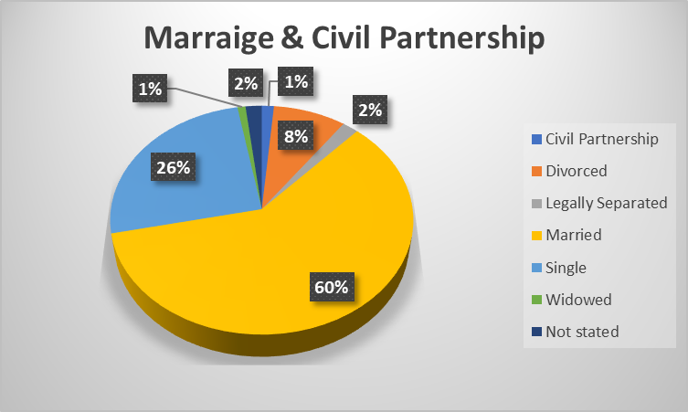
Figure 7: Distribution of MSE employees by marriage and civil partnership

Of the senior managers within the ICB (band 8c and above), 56 were female (64%), and 32 male (36%). Data shows that overall, there are a higher proportion of men in higher banded positions in the ICB than in the lower bandings as shown in figure 8. Data further shows that women earn 10.6% less than men overall, according to the median pay gap data and 20% less than men according to the mean pay gap data.

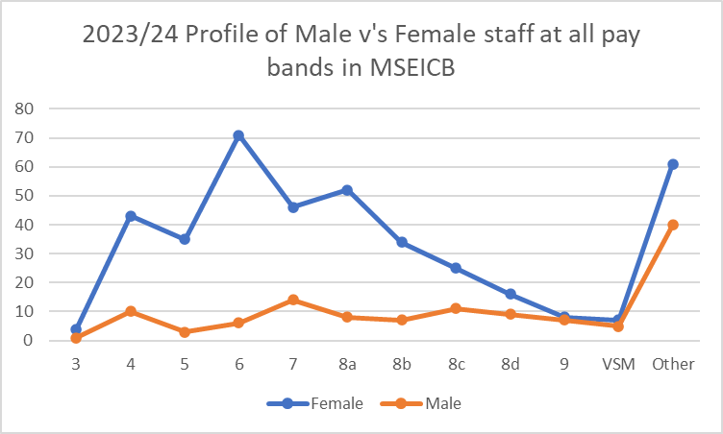
Figure 8: Gender profile within staff bands.

The ICB will therefore continue to monitor and take steps to address the gender pay gap (higher proportion of women paid at lower bands).

Conclusion

Annually, the ICB reports on the Workforce Race Equality Standards (WRES) the Workforce Disability Equality Standards (WDES) and the Gender Pay Gap; to comply with statutory reporting requirements and to better understand what further actions we may need to take to continue to address identified inequalities. The ICB has performed well in achieving a better representation throughout the ICB. For example, staff with a disability have an equal chance of being appointed but there remains disparity in terms of the appointment of staff from ethnically diverse backgrounds. There is also a new requirement to publish an Ethnicity Pay Gap Report. These will be reported to the ICB Board alongside a detailed action plan outlining the steps that will be undertaken to better understand equality of opportunity and ensure that the ICB takes every possible step to ensure equitable access, such as adjusting our recruitment processes to even up the likelihood of those from non-white heritage applying and being appointed to positions in the ICB.

Our latest published WRES, WDES and Pay gap reporting can be found here Gender pay gap - Mid and South Essex Integrated Care System (ics.nhs.uk) [hyperlinks]

As part of our strategy, we recognise that we can do more to interpret the data available regarding our staff and consequently, we will be looking at how we assess intersectionality; the experience of staff with more than one protected characteristic and what the ICB can do in the future to support staff in this respect

The ICB respects individuals right to not disclose information they consider personal to them, but where this inhibits the ICBs ability to support staff with a protected characteristic, we will endeavour to understand why staff did not feel able to disclose such information and consequently what else the ICB could do to improve staff psychological safety to disclose and the ICB ability to support staff.

Arrangements for Review

Following publication of our EDIB Strategy the ICB will provide an annual report to the ICB Board regarding compliance with the PSED and how the ICB is progressing in achieving its equality objectives.

