


MSE Integrated Care Partnership, 13 March 2023

Agenda Number: 8

Delivering the Integrated Care Partnership Strategy

Summary Report

Purpose of Report
To highlight progress in discussions to agree priorities and a supporting delivery plan to support the Integrated Care Partnership (ICP) Strategy

Executive Leads
Emily Hough, Executive Director, Strategy & Corporate Services, Mid and South Essex ICB
Peter Fairley, Director for Strategy, Policy and Integration, Essex County Council
Krishna Ramkhelawon, Director of Public Health, Southend-on-Sea City Council
Sara Godward, Consultant in Public Health, Thurrock Council

Report Author
Emily Hough, Executive Director, Strategy & Corporate Services, Mid and South Essex ICB

Responsible Committees
Integrated Care Partnership

Link to the ICP’s Strategic Objectives
ICP Strategy Common Endeavour to Reduce Health Inequalities

Financial Implications
N/A

Details of patient or public engagement or consultation
The ICP strategy was developed with engagement from stakeholders across the ICP.
The ICP’s Community Assembly asked for their views on the emerging priorities at their meeting on 7 February.
Further engagement will continue to take place as the delivery plan is developed.

Conflicts of Interest
None identified.

Recommendations
The Integrated Care Partnership is asked to note progress in identifying a set of priorities for MSE to focus on in delivering the ambitions of our ICP Strategy.

Delivering the MSE Integrated Care Partnership Strategy

Executive Summary
In December 2023 Mid and South Essex (MSE) Integrated Care Partnership (ICP) agreed to establish an ICP Delivery Group to agree priorities and develop delivery plans for those priorities for the next financial year. The terms of reference for the group are provided in Annex 1.
The group has now met twice, on 19 January and 16 February, with a further meeting planned for 18 March. Through these meetings, and engagement with other stakeholders in the system including the Community Assembly, a set of five priorities have emerged. These priorities were selected using an agreed set of selection criteria that take account of areas where there is a known area of need and opportunity for the ICP to do more collectively than the individual organisations can do alone.
The five priorities for a health MSE are:
- Healthy Starts
- Healthy Hearts
- Healthy Minds
- Healthy Weight
- Healthy Housing
Work is currently underway to develop more specific ambitions for the priority areas for 24/25, which will be set in the context of the longer term ICB strategy. Specific actions to deliver on those ambitions will also be worked up and agreed across the partnership.
The priorities identified through this process provide a focused set of areas for partners across the ICP to drive increased collaboration on in 2024/25, noting that there are a wide range of other collaborations underway across MSE at a system and place levels to support residents manage their health and wellbeing.

Developing a list of priorities for the ICP
An initial long list of potential priority areas was developed following a discussion with the Delivery Group in January. The list of priorities was informed by priorities from individual Health and Wellbeing Boards and Integrated Care Board (ICB) priorities, as well as insights from members of the Delivery Group and insights on current performance and quality needs across MSE.
Alongside the long list of delivery priorities, the Delivery Group noted the importance of both considering how we work together in partnership to meet the health and care needs of the population of MSE, including where in the system programmes will be led from and how we utilise our collective assets to deliver the best outcomes for the population of MSE. The importance of strengthening our Partnership and developing our Enablers will underpin all delivery priorities that are agreed.
The ICP Delivery Group also agreed a set of selection criteria for the ICP priorities that noted the importance of selecting priorities that focus on how we can work together to have impact for residents. The selection criteria were that priorities have to:
- Add value to the system, over and above what individual organisations can do
- Include cross boundary working, either due to scale or boundaries are artificial
- Not duplicating existing efforts
- Be an area where the risk of not doing something is too great
- Have demonstrable outcomes associated with activity
- Be feasible to deliver
Reflecting on individual and system priorities, as well as these criteria, the ICP Delivery Group developed an initial long list that includes:
- Cancer
- CVD
- Respiratory Disease
- Dementia
- Neurodiversity
- Healthy weight management
- Smoking cessation
- Drug / Alcohol use
- Health checks (specifically for people with Learning Disabilities and autism)
- Housing
- Education (specifically relating to health literacy)
- Employment
The long list of delivery priorities was tested with members of the MSE Community Assembly who attended the meeting on 7 February 2024. In the session, members of the Assembly were asked to share their views on the MSE ICP Strategy’s ‘Plan on a Page’ (See figure 1), the long list of delivery priorities and areas where they feel they could best contribute to delivery.
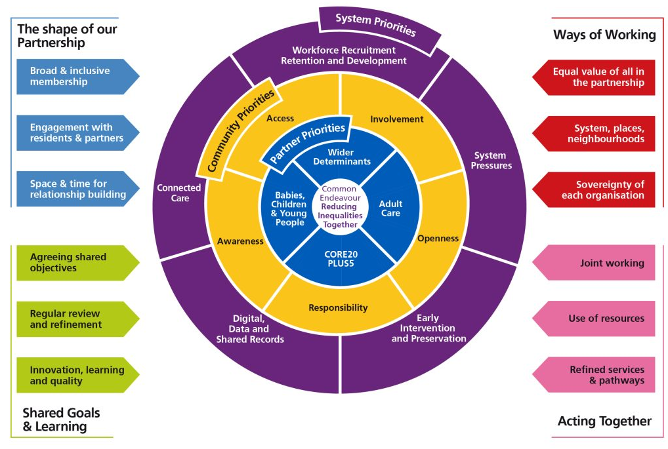
Figure 1: ICP ‘Plan on a Page’

Figure 2 sets out a word-cloud of the areas that the Community Assembly identified as being most important to them from the ICP ‘Plan on a Page’. Early Intervention, Prevent, engagement with residents and community were identified as the priorities by those at the meeting.

Figure 2: Community Assembly reflections on priorities within the ICP Plan on a Page
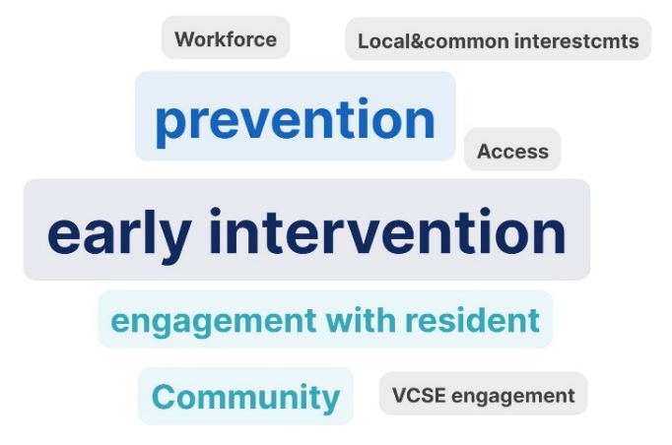
The Community Assembly were invited to vote on the initial ‘long list’ of priorities that were identified by the ICP Delivery Group to identify the areas they considered to be a priority. Babies, children and young people was identified as the top priority area, followed by neurodiversity, healthy weight management, respiratory disease and health literacy. Assembly members were also invited to nominate ‘other’ priorities, with Mental Health being highlighted as a priority by at least five members of the group.
At the February ICP Delivery Group, the long list and the input from the Community Assembly was reviewed and considered against the selection criteria. This led to a short list of five priorities:
- Healthy Starts: Babies, children and young people
- Healthy Weight: Healthy Weight Management
- Healthy Hearts: Cardiovascular Disease
- Healthy Minds: Mental Health
- Healthy Housing
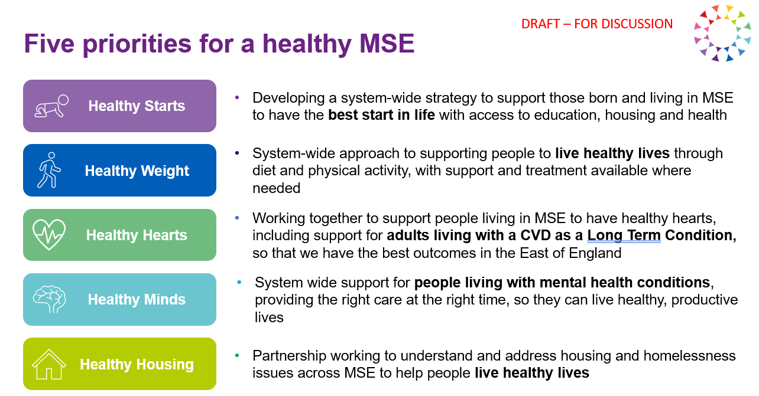
These priorities align with the ICP’s partner priorities to work together on tackling wider determinants of health and tackle health inequalities across both adult and children’s care services. They also align strongly with the priorities identified in the council Health and Wellbeing Boards and the ICB’s Joint Forward Plan.

Developing delivery plans for the priorities
The five priority areas identified by the ICP Delivery Group are broad, and therefore specific targets or ambitions and supporting delivery plans for 24/25 need to be developed. These will be evolved from existing partnerships and work across the system and will explore opportunities to spread best practice across MSE, as well as testing and implementing new approaches to improve health and wellbeing for all residents, with a focus on addressing health inequalities:
- Healthy Starts: this will need to consider opportunities to build on and strengthen alignment between the current MSE Growing Well Board, the Essex Children and Young People’s Strategic Partnership and work within each Health and Wellbeing Board relating to the biggest issues facing children and young people in MSE. Potential areas of focus for this priority that have been raised so far include: support for children with Special Educational Needs and Disabilities (SEND), Children’s Mental Health and Oral Health in Children.

- Healthy Weight: weight is a significant driver of many health outcomes and obesity rates in children and adults are continuing to increase in MSE. Local commissioned services are supporting people to live healthy lifestyles and weight management services are available through both local authorities and the NHS. However, success through those programmes is variable across all Tier 2 service offers (dedicated behavioural intervention) and this is leading to more demand to access Tier 3 services (more intensive intervention which may include weight loss medication). Work is underway to consider options to better coordinate current Tier 2 services to spread best practice and maximise the impact of support available to residents, especially across our most deprived communities

- Healthy Hearts: Cardiovascular disease (CVD) is one of the major drivers of mortality attributable to socioeconomic inequality in MSE. Within the East of England, Thurrock has emerged as being a leader in supporting patients with CVD to manage their condition. However, MSE as a whole remains a poor performer. Addressing this by identifying patients with CVD and help them manage their condition more effectively through demonstrated best practice in prevention and treatments is a shared ambition across the ICP.

- Healthy Minds: Supporting people to manage their mental wellbeing is important for both individuals and communities. MSE is part of the broader Southend, Essex and Thurrock Strategic Implementation Group (SIG) which is considering how we can better support people living with Mental Health conditions. This group is being asked to consider what our immediate ambition should be to support individuals and communities, including what focus there should be on prevention as well as recovery.

- Healthy Housing: Housing is a key determinant of health and is a regular issue arising through Alliance conversations. Much of the work around housing happens through local partnerships, but there are no doubt opportunities to learn from each other and tackled some of the shared challenges at a system level. The main areas highlighted for consideration in relation to this priority so far include supporting those who are homeless or at risk of being homeless, addressing poor quality housing that risks exacerbating health and the potential impact housing growth may have on future demand for services. Initial conversations are planned with Basildon Council, Southend and Thurrock to explore these issues and identified a shared ambition.

Next steps and recommendations
Proposals for each of these areas will be brought back to the ICP Delivery Group meeting on 18 March for further discussion in the hope of agreeing a specific ambition for 24/25 and associated actions to deliver on that ambition.
The March meeting will also consider how progress against the ambitions can be monitored across the ICP, and how discussions on the priorities can be progressed through ongoing partnership discussions.
The Board is asked to:
- Confirm support for the emerging five priorities for a healthier MSE
- Note progress in developing specific ambitions and supporting delivery plans for each priority area

Annex 1: MSE ICP Delivery Group Terms of Reference

Purpose
Mid and South Essex (MSE) Integrated Care Partnership (ICP) published its Integrated Care Strategy for 2023-2033 in March 2023. Since then, members of the ICP have been working collectively to improve the health and wellbeing of the population of mid and south Essex. However, a delivery plan to implement commitments in the strategy has not yet been developed.
At the ICP Board meeting on 6 December it was agreed that a Delivery Group would be established to agree priorities and develop delivery plans for progressing implementation of the ICPs priorities in 24/25.

Delivery Group Objectives
As a time-limited task and finish group, the Delivery Group will meet three times between January and March 2024. It will have an explicit focus on agreeing a set of share system priorities that ICP members will work together to progress during 24/25.
The priorities will be drawn from those set out in the ICP Strategy, as well as the underpinning organisational plans that were used to inform its development. The Delivery Group will be expected to draw on quantitative and qualitative data to inform the prioritisation of activities for 24/25. The Delivery Group will also be expected to have due regard to the current financial position across MSE ICP partners and focus on opportunities to maximise on existing projects, programmes and resources to progress the commitments in the ICP Strategy.
The Delivery Group will aim to:
- Agree a defined set of priorities for ICP members to work together to progress during 24/25
- Recognise the work that is being progressed within individual member organisations and focus priorities that:
  - Focus on areas that no-one has sufficient focus on currently
  - Support spread of best practice from one area to another
  - Will deliver better value through a system-wide focus
- Capture opportunities to share planned work beyond the agreed priorities that can add value across the ICP
- Develop a high level work plan for agreed priority areas that includes:
  - A ‘project’ lead from one of the ICP member organisations
  - Supporting resource from other member organisations
  - High level deliverables / commitments for the year
  - A timetable for reporting on progress to the ICB re: that priority
  - Any additional financial requirement to progress proposed projects across the priorities

Governance
The Delivery Group is being established as a time-limited task and finish group that will meet three times between January and March 2024.
The Group will report directly into the Integrated Care Partnership Board, with an update brought to the ICP in March.

Membership
Proposed membership for the Delivery Group includes:
- MSE ICB Executive Director, Strategy & Corporate Services (Chair)
- Essex County Council Director for Strategy and Health Integration
- Thurrock Council Director of Public Health
- Southend Council Executive Director (Adults and Communities)
- Southend Director of Public Health
- MSE FT Chief Strategy and Improvement Officer
- EPUT Executive Director of Strategy, Transformation and Digital
- NELFT Executive Director of Partnerships
- MSE Community Collaborative Transformation Director
- MSE Executive Chief Nurse
- MSE Allied Health Professionals Director
- MSE Chief Finance Officer
- MSE Chief Digital and Information Officer
- Alliance Directors (at least 1 to attend each meeting)
Members can send a deputy if they are unable to attend.
Members of the group will be expected to engage with colleagues from across their organisations, ensuring that as a minimum they get input on both priorities and delivery plans from:
- Place-based teams
- Adult services
- Children’s services
- Public health
- Quality and safety
- Workforce
- Digital
To ensure that the local voluntary, community, faith and social enterprise (VCFSE) sector are able to share their views with the Delivery Group, the MSE Community Assembly will be engaged in discussing priorities and delivery plans. Councils and Place Based Teams (Alliances) will also be expected to engage with their local partners to ensure their views are included in discussions.

Expected Behaviours
To enable the Delivery Group to meet its aims and objectives, the following behaviours are expected of all Members:
- Participate in debate respectfully to foster a supportive and collaborative working environment withing the Group
- Commit the time necessary to understand the issues and proposals being considered by the Delivery Group
- Consider opportunities to improve population health and reduce health inequalities for the population of MSE through collaborative work
- Declare any conflicts of interest relevant to the work of the Delivery Group

